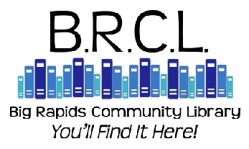

Dear Parent:

For every child, obtaining a library card is an important event. Library cards are a ticket to the world of learning and the enjoyment of reading. The Big Rapids Community Library offers programs throughout the year to encourage your child to read and learn.

Currently, your child attends one of the many schools in Big Rapids that work to foster a love of reading. As part of that mission the school will be participating in a program offered by the Big Rapids Community Library called the “Big Rapids LET’S READ Program” (Library Enriching Teachers & Students as Reading Education Advocates).

By filling out the form below and having your child return it to their teacher, you will give your child the opportunity to receive a library card. This card will be used in the child’s classroom to check out materials loaned through the library to the school. This card can also be used at the Big Rapids Community Library outside of a school setting.

It is the policy of the Library that a parent, or legal guardian, of a minor child under the age of 18 signs for their child’s library card. Your signature indicates responsibility for materials borrowed on your child’s card.

Circulation Policy Excerpts For Card If Used in the Big Rapids Community Library
- Books & Audio-Books – Most items checkout for three weeks. Overdue fines are $.15/day up to a maximum of $10.00 per item.
- DVD & Blu-Ray – Items checkout for one week. Overdue fines are $1.00/day up to a maximum of $10.00 per item.
- Most items are renewable if not being held for another patron. Items can be renewed in person, by phone, through e-mail or online.
- eBooks and online homework help are also available through the library as well as programs and events.

We look forward to providing many years of reading and learning opportunities for your family.
Sincerely,

Miriam Andrus, Director
Big Rapids Community Library

Acknowledgment of Responsibility for Child’s Library Card
(Please Print Clearly)

I accept responsibility for my child’s use of this library card with the Big Rapids Community Library. I agree to pay for any fines incurred and for lost or damaged materials.
Child’s Name: ____________________________________________ Child’s Date of Birth: _______________________
Address: ________________________________________________ Phone: ___________________________________
City: ___________________________ ZIP Code: ____________ Township: ________________________________
E-mail: ______________________________________________________________________________________________
Driver’s License or State ID #: ___________________________________________________________________________
Your Name: _____________________________________ Your Signature: ________________________________________

